
12 ATAR Physics

Hubble's Law (Part 2) 2019

Name: Mark: $\frac{}{\text{27}}$

The Big Bang Theory & Hubble’s Law

1. Using the data points collected previously in part 1, plot a correctly-labelled graph to determine an accurate value of Hubble’s constant. [4 marks]



2. Use the graph to calculate a value for Hubble’s constant, including the correct units. [4 marks]

3. Determine the age of the universe (in billions of years) according to the data you have graphed.
[4 marks]

4 A line in the spectrum of ionised potassium has a wavelength of 422.3 nm when measured in the laboratory. When similar light from the galaxy NGC 5170 is measured, its wavelength is 424.4 nm.

(a) Calculate the red-shift of this galaxy. [3 marks]

(b) Calculate the recessional speed of this galaxy in kms⁻¹. [3 marks]

(c) For the recessional speed previously calculated, use your graph to determine the distance to this galaxy in Mpc. [1 mark]

(d) Determine how many years it takes for light from galaxy NGC 5170 to reach Earth. [2 marks]

5. (a) What is meant by the term "red-shift"? Use the following diagram to assist your explanation. [2 marks]

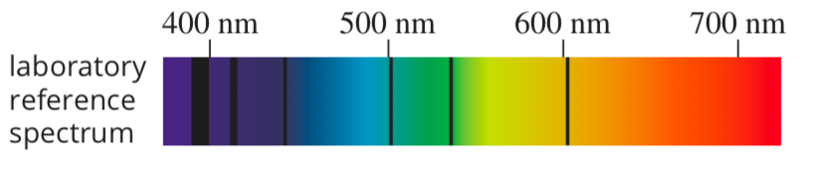

(b) What did Hubble find when he observed the light from distant galaxies, as compared to light from closer galaxies? [2 marks]

(c) How do Hubble's observations support the concept of an expanding universe?
[2 marks]

